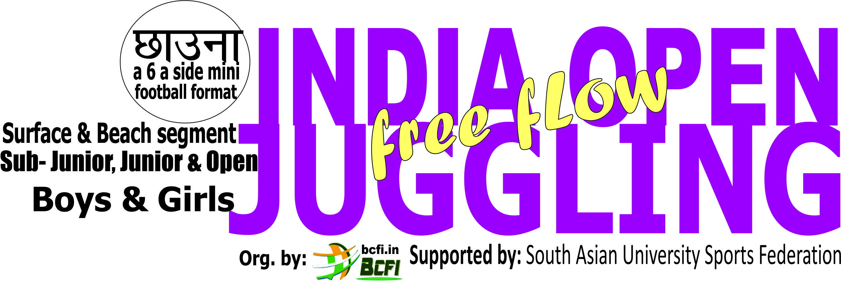
Part of selection for Indian squad
Org. by: बोर्ड ऑफ़ छाउना फेडरेशन फॉर इंडिया
Board of CHAUNNA Federation for India
Jointly supported by: International Aviation Games, Asian CHAUNNA Soccer Confederation,
Bhartiyam Sports, POONA Racket Federation, South Asian University Sports Federation
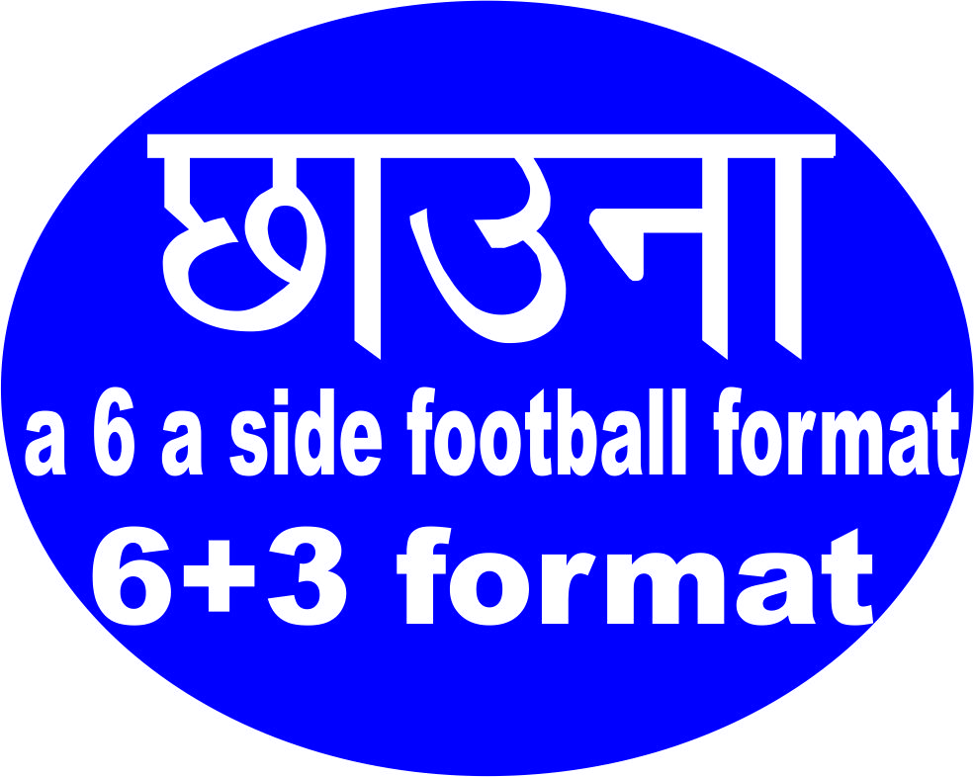

20th Oct. – 10th Nov. (result on 25th Nov.)
Video shall be continue & uninterrupted and

Use bowl No.4, Segment: Boys & Girls for surface & Beach
MAX. TIMIING 60 sec., including your name intro, city, state/province & country (NRI/OCI)

Category Boys: (Sub- Junior & Junior)
Sub- Junior- Under- 14 (On 1st June 2007 or after)
Junior Under- 18 (On 1st june 2003 or after)
Open division above 18th

Category Girls (Sub- Junior & Junior)
Sub- Junior, Under 14 (On 1st June 2007 or after)
Junior, Under- 18, (On 1st June 2003 or after)
Open division above 18

Top players will be deciding on max. free flow juggling in giving time + likes on our app.
First put ur video on Chingari App. Write your Chingari ID, and send to us with fill form+ receipt.

IMPORTANT: An Indian living in other country may a represent their existence country.

Registration system: First video, an Indian living in India @150/-per category & per segment & NRI/ PIO/ OCI @Rs.350/-
Board of CHAUNNA Federation for India, HDFC Bank, A/c No.50100 3497 43882
IFS Code-HDFC0009042 At Preet Vihar, Delhi

1ST Round (IOJ with 60 Sec.), Part of selection for Indian squad
Keep note, if you are not attaching bank/online payment’s screenshot, you will not be entitled to take part

Every participant who secure min. 100 like will get e- certificate of participation from National Federation for this round. Only top 30 players of each segment & category will go for final selection round.

We may keep your video for maximum 7 days on-board to get maximum likes.
To get more like, you may need to send more clipping with an additional cost of @100/- per time and we will send you link to get likes accordingly. NRI/ PIO/ OCI - For an every next Video @150/-only.

Your First VIDEO likes & comments + ADDITIONAL Video like and comment, will be calculate for next round. In case you are completing for Asian/ World round, your likes & comments pf previous rounds will calculate there as well.

2nd Round (MJ with max. time) Part of selection for Indian squad,in Jan.

For Continental / World JUGGLING championship , you may need to compete selection process to represent country - Top 30 players from first round (IOJ with 60 Sec. free flow video clip) & top 30 players from Second round (MJ with maximum time free flow juggling) in each div. & category, may need to compete with each other to enter in squad of 30 players of India.

Winners will decide through your performance cum TOTAL NUMBER of likes & comment on social media will calculate to get participation in next round. 30 top players of each segment & category will send in final selection round.

Selection of Indian squad based on likes & comments and top 6 players, who secured place in Indian squad after both rounds, may get prize money & permission for an International in 2021
PRIZE MONEY IN EACH SECTION & SEGMENT
Sub- Junior, Junior & Open (Boys & Girls),
in Field & Beach Segment (Min. 100 participants)
Champion INRs 10,000/-,
Runner INRs 05,000/-
3rd Place INRs 02,500/-
Fourth & Fifth @ INRs 01,250/-
Sixth place 1000/-
If you are winner in both rounds, you may not need to compete for final selection
INDIA OPEN JUGGLING
Register on : www.bcfi.in
Part of selection for Indian squad
Command office: DA-18 (1st Floor), VikasMarg, Delhi – 92, India
Send all docs & videos to Email - INDIANCHANNA@gmail.com
Venue: Send your video clip, As per applied format
Last Date 10.11.2020

Participation Form
FULL Name:Click here to enter name.
Referred by:Click here to enter reference Mobile/Emailid:Click here to entermoble/emailid.
EmailID:Click here to enter email ID
Social Media:Facebook:Click here to enter text. Twitter:Click here to enter text.
Instagram:Click here to enter text.Other media:Click here to enter text.
Mobile1:Click here to enter mobileMobile2:Click here to enter mobile.
Gender: Male/ Female / Date of Birth:Click here to enter a date.
Height:Click here to enter height. Weight: Click here to enter weight.
Address:Click here to enter address.
City/District:Click here to enter city.Pin Code:Click here to enter pincode.
Country:Click here to enter country.

Attach a clear photo/Selfie sports dress:
Attach a clear address & photo Identity:
Last date of sending video clip for primarily round till 10th Nov 2020
Send filled form with all attachments to indianchaunna@gmail.com
Participation has been open in any number of categories (as given rules): fill your Category
__________/_________/_________/________/
Sending 1st time ☐ 2ND time ☐ 3RD time ☐ 4TH time ☐

Fill below, so nothing will miss for record

Name of Bank :Click here to enter name.Country:Click here to enter country

Payment Ref Number:Click here to enter ref.no.Amount:Click here to enter amount.
Dated:Click here to enter a date.
Send screen/ photo shoot of your pay slip along-with filled form on above email, WE WILL SEND YOU REGISTRATION NUMBER for further communication & link to get more like on your video clip.

DECLARATION : I read all terms & conduction about participation, I am giving my NOC to use my Video & Photos to promote this event now and in futures as well in by BCFI in any shape. I UNDERSTAND that only quality video will be uploading and I will not claim on my rejection & will resend with re-payment of fee with fresh video. I, am always abide with all rules & regulation meant by BCFI for participation on time to time basis.

Name:Click here to enter name.Date:Click here to enter a date.

☐
Mark TICK mean, I read & understand all t & c

Keep note there is no any refund policy
STAY AT HOME to STAY SAFE

